**Prova 1 Sinais e Sistemas**

Vitor 11621ECP010

Enio 11621ECP011

Samuel Antonio Queiroz de Souza 11511ECP012

**Q1)**

MAT1: 11621ECP010, KANO1: 3, KCUR1: 3, KNUM1: 2

MAT2: 11621ECP011, KANO2: 3, KCUR2: 4, KNUM2: 3

MAT3: 11511ECP012, KANO3: 1, KCUR3: 2, KNUM3: 4

**Q2)**

A)

F0 = 10·(2 + 3 + 4) = 90 .

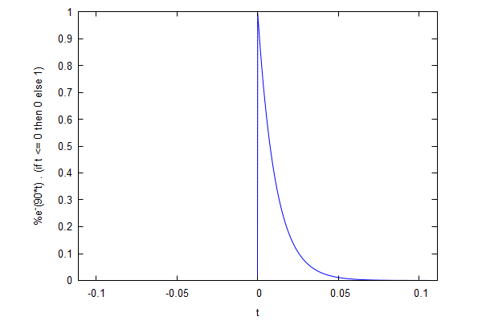Y1=

Y2=

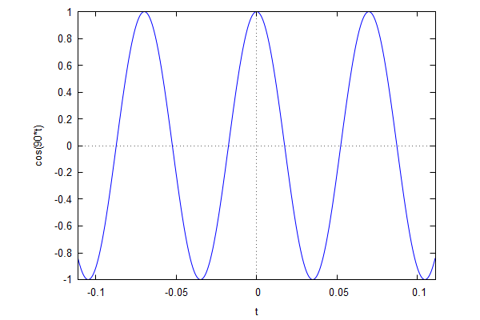real

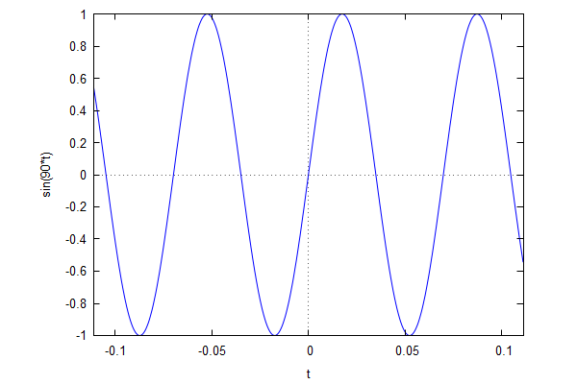

parte imagnaria

Y3=

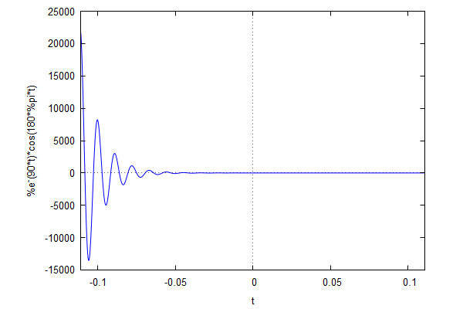parte real

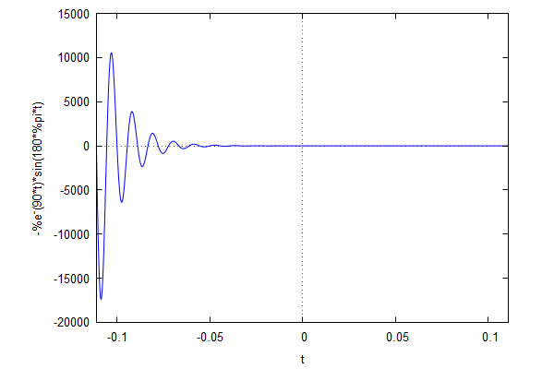

parte imaginaria

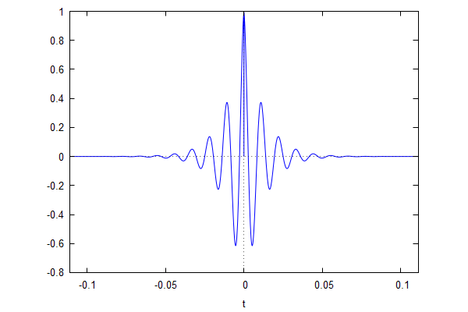Y4=

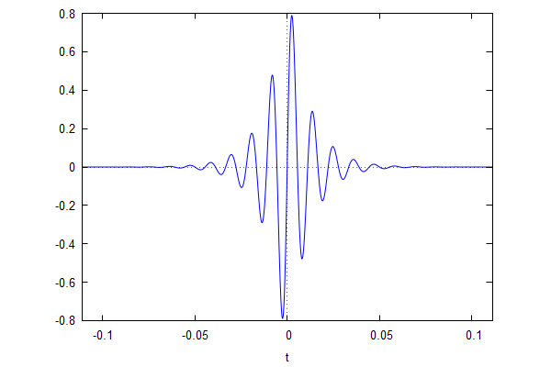B)

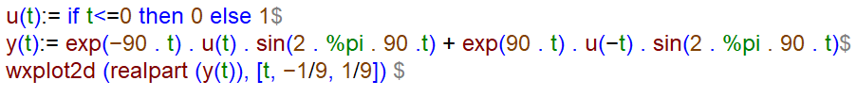

**Q3)**

**1. 3 e 3; 3 e 3; 1 e 3.**

**2. h[n] = 3sigma[n-3] + 3sigma[n-3] + sigma[n-3] => h[n] = 7sigma[n-3].**

**3. Dado: {2,-3,4,-1,1,1}, sendo assim: 2 e 3; -3 e 3; 4 e 3; -1 e 3; 1 e 3; 1 e 1.**

**4. x[n] = 2*sigma[n-3] + (-3)*sigma[n-3] + 4*sigma[n-3] + (-1)*sigma[n-3] + 1*sigma[n-3] + 1*sigma[n-1] => x[n] = 3*sigma(n-3) + sigma(n-1).**

**5. y[n] = x[n] * h[n] => y[n] = (7*sigma[n-3]) * (3*sigma(n-3) + sigma(n-1))**

**Q4)**

